30

An Exhibition Celebrating the Thirtieth Anniversary of Hal Bromm Gallery

Contents
An Introduction to the Exhibition by Hal Bromm
An Invitation to Participate in the Exhibition

“To Be Young, Gay, Gifted, and Dead: Four Artists in the Eighties” by Dan Cameron

“Untitled” by Lucio Pozzi

“Intermediate Interment” by Carlo McCormick

“Sur’s Inquiry: Is Any of this News” by Sur Rodney (Sur)

“Luis and David Among Others” by Stephen Lack

“Carta a Luis” by Lia Frangella-Malacorto

“Fade Away and Radiate” by Barry Blinderman

“FLASH IN OUR WORLD: Carlos J. Alfonso” by Cesar Trasobares

Exhibition List

Following is a letter sent by the gallery to art critics, art dealers and friends by the gallery to contribute to the exhibition and this catalogue

HAL BROMM GALLERY

90 WEST BROADWAY NEW YORK 10007 (212) 732-6196

August 7, 2007

Dear Friends,

Hal Bromm Gallery is preparing a thirtieth anniversary exhibition for October titled "30" featuring works by four artists who had early solo shows with the gallery but whose lives were cut short by AIDS: Carlos Alfonzo, Luis Frangella, Keith Haring and David Wojnarowicz.

We also plan to have a catalogue and a series of salon events to include readings by friends of the artists, curators, and others. The catalogue involves some research into the correspondence and journals of the artists. Your guidance concerning research of this nature will be a significant help. If you know of anyone who may like to contribute to the catalogue and reading series, please let us know. Your thoughts and ideas on works we might borrow for the show would be much appreciated.

You should feel you are part of the process of developing the exhibition, with an open door to comments, suggestions, and criticisms… we would like to invite you to contribute – as you see fit – to the exhibition’s development in any way. Also, if you think of potential lenders, recall favorite works by the artists, or own works you might consider lending, let us know.

We look forward to your input and contribution.

Sincerely yours,

Hal Bromm Gallery

TO BE YOUNG, GAY, GIFTED, AND DEAD
Four Artists in the ‘Eighties
Dan Cameron
There is still a big hole in the art world where many of the artists of my generation used to live. From the early 1980s until about halfway into the 1990s, AIDS was a scythe, leveling every layer of acquaintanceship: the artists you admired, the neighbor that got on your nerves, the cute guy you met at the bar that night. There were certainly points when it seemed that AIDS encompassed everything and everybody one knew, even when one tried (I’m certainly guilty of this) to push it as far from one’s thoughts as possible. Even today, you sometimes notice the shortage of gay male artists in the early-50s-to-early-70s generation, because these are the ones whose sexual emancipation took place in the 1970s, meaning that they were on the front lines, demographically speaking, when the infection first took hold.
I moved to New York in 1979 and began publishing art criticism and organizing exhibitions within a year or two, so Keith Haring, David Wojnarowicz, and Luis Frangella were all people whom one knew, in the sense that one saw them, nodded and smiled at them, and occasionally exchanged a few words at a party or a club. Of the three, Luis is the one I came closest to knowing -- in the sense of our having friends in common and spending time together -- and I remember having the distinct sense (although my sense of social awkwardness may have been a factor here) that Keith and David occupied a more rarified atmosphere, because they were already been widely recognized for their very earliest work.
Carlos Alfonso was a completely different figure in social terms, having been a Miami Cuban whose relationship to New York was fairly remote. One might speculate on what might have happened if Alfonzo had in fact made his way to New York early on and stayed there for several years, but the fact is his existence unfolded inside a parallel universe, partly because his sexual identity was, for years, something about which he had considerably more ambivalent feelings than his New York contemporaries, all of whom were publicly out and proud. Because his stylistic development was also very much a matter of personal improvisation on historical material, Alfonso references the abstract expressionist roots of neo-expressionism with a directness that by comparison is only whispered in the work of Frangella and Wojnarowicz, and all but ignored in Haring’s.
Toward their various bodies of work, I continue to have widely differing reactions. Because the photo-appropriation paradigm had not fully supplanted the post-expressionist mode of working until the late 1980s, it was possible for a critic and curator to maintain an eclectic position vis-à-vis these warring camps for a long time, so I did. Haring was (and continues to be) the most problematic figure of the three in terms of the meaning and importance of his art. As much as I enjoy it, I have not been able to completely expunge the idea that he is primarily a maker of shapes and outlines, a children’s cartoonist who happened on an ingenious method for drawing attention to his work. When it came to graffiti-inspired art, I preferred (and still do) to look at the real thing (Lee Quinones, Futura, Lady Pink), or at a more painterly hybrid (Basquiat, Scharf) than Haring’s visual simplicity permitted.
Luis Frangella is still something of an historical enigma, not least because his art helped pave the way for a more analytical approach to the figure at a time when figuration was splintering in too many directions to keep track of. Formally trained as an architect, Frangella possessed a schematic flair for transforming standardized images into icons framed by visual effects, and many of his paintings treat images familiar from advertising as romantic motifs
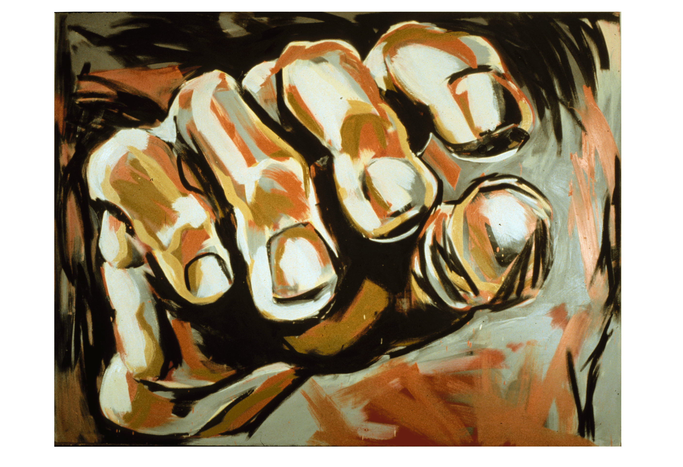
Luis Frangella, Early Seduction, 1983, oil on canvas, 92” x 120”.

drifting into a heroic mist. Behind it all, one gets a sense of the artist as a chameleon, able to change his appearance to match his attitudes, leaving behind a small but persuasive body of work that is transparent, elusive, and oddly bereft.
Eight years after organizing a retrospective of his work, I continue to view Wojnarowicz as the artistic giant of the four, effortlessly tying together genres, styles, and media as if they were elements in a collage. As the Renaissance Man of the East Village, he was the one artist who threw himself into virtually every possibility that lay in front of him, whether it was painting, photography, performance, politics, video, music, sculpture, or poetry. By the time of his death in 1992, Wojnarowicz was better known for his AIDS activism than his art, but this prominence has gradually reversed itself in the fifteen years since, making his overall contribution one of the central reference points for New York art during the turbulent 1980s.
An interesting final point to make is that of the four, Wojnarowicz is also the only one who transformed the end of his life into a kind of walking advertisement for his condition. Keith Haring was also an activist, but he was notably catholic about which charities he helped with his gifts, and he tended to trade off his fame as much as his art, so that one never knew what he was feeling by looking at his pictures. This was even more the case with Alfonso and Frangella, artists who worked with at least one foot in the metaphysical. It is probably safe to say that if any one of the four was still alive and working, if the plague had somehow passed him by, the art world would not be quite the place it is today. Considering that the number of their professional peers who also died prematurely reaches well into the hundreds, it is tempting but futile to think that if the whole thing had never happened, the New York art world might also have evolved into a funnier, more generous, and somehow more liberated place to be.

Dan Cameron is a well-known curator and critic of contemporary art. He has previously written about Luis Frangella's work ("Object Lessons: Notes on the Art of Luis Frangella," The Art of Luis Frangella, InterAmerican Center, Mitchell Wolfson New York Center Campus, Miami-Dade Community College) and organized an exhibition of David Wojnarowicz's work at the New Museum ("Fever: The Art of David Wojnarowicz," January 21 – June 20, 1999). Cameron's essay “To Be Young, Gay, Gifted, and Dead: Four Artists in the Eighties” reflects on the devastating loss of so many gifted artists to AIDS, and their unrealized artistic potential.

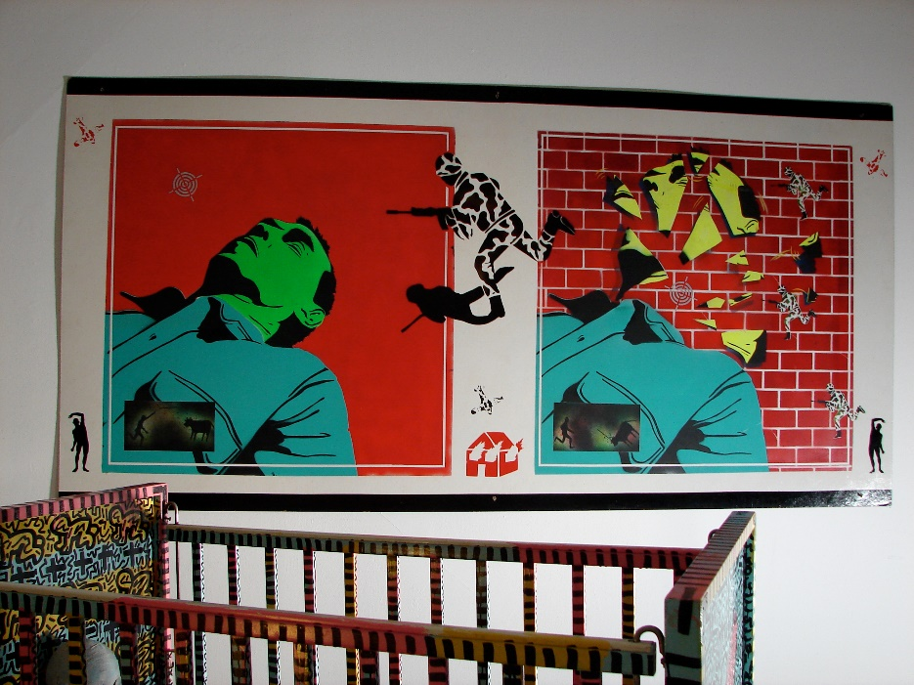
Exhibition installation view: (foreground) Keith Haring, Untitled (Crib), 1981, enamel and marker on wood, 42” x 55” x 30” Private Collection; created for and first exhibited at Hal Bromm Gallery in December, 1981 in “Keith Haring”, the artist’s first ever solo exhibition in a New York gallery. (background) David Wojnarowicz, Untitled (Green Head), 1982, Acrylic on Masonite, 48” x 96”, Private Collection; created for and first exhibited at Alexander Milliken Gallery in 1982 at “Fast” exhibition.

Untitled
Lucio Pozzi
1 September 2007
I met Keith Haring when he was a student in my third-year class at School of Visual Arts in New York. He was painting in acrylics on long rectangular papers placed on the floor. He composed patterns of sensibly applied layers of paint that ranged from transparent to opaque, in loose squarish brushstrokes vaguely reminiscent of Bradley Walker Tomlin’s works of the fifties.
One day, he invited me to a room where he showed me very many black and white video works that he had been producing that year. They were snippets of his and his friends' everyday life captured by a restless hand-held camera. Young men were walking around naked in a kitchen or in daily clothes chatting in a room. I don’t remember there being any specific narrative being told in these tapes. The subject matter was the camera itself and the flow of life, aimless, matter of fact, playful, sad, whatever the spectator would wish it to be. I still think of Keith’s videos as among the most intense pieces of his art.
As his activity on the subway walls increased and so much else happened to him in the city, he asked me what I thought about his quitting school before graduation - was staying in school still needed. I told him I got no degree after my high school diploma and here I am teaching in prominent universities in order to share thoughts about how to change art around. I couldn’t advise. He quit.
Next, he called asking that I drop by in the basement of Tony Shafrazi’s gallery on Mercer Street. I found him on the floor frantically marking sheets of paper with hundreds of patterns of uninflected ink or paint representing stick figures of all kinds of people, animals, botany and signs. I commented that such a flow of production could disperse the sensibility of his painting. He answered: why? He was already on the way towards his goal of making art accessible to wider publics and that meant reduction of subtleties and increase of generic focus.
His themes were simple, like the themes in the video works. They were specific enough to be recognized, yet general enough to be disengaged from topical anecdote: man, woman, baby, sex, fall, sleep, standing, lying, build, break, mask. He picked the Molas, ancient polychrome bustling patchwork cloths stitched by the Kuna women of the San Blas Islands off Panama, as a model for developing large decorations of interlocking figures in contrasting colors. The resulting effect was one of visual fun containing the joys and dramas of life.
He moved to the Cable Building in a studio facing Houston Street. I lived across the street and so it would happen often that we crossed paths and we would chat. Keith was never conceited, his eternally surprised eyes framed in thick shortsighted glasses always wide open and attentive and extremely respectful of whoever he would talk with. Knowing how much I care about matching the accessible side of painting with the ambiguities of personal touch, he often told me to come see how he was now exploring that aspect of his painting again. The market gobbled him up and disease didn’t leave him the time to push further, but certainly how many of us can see our art carried on T-shirts, printed on curtains, decorating dishes, hanging on the walls as fine paintings in Nigeria and Siberia and Nebraska and Brazil and London and Moscow? He has invented a way to make art which is one and the same with its distribution in a global mass society and is not a sellout and never seems to tire us. What he achieved was but a utopia for the Delaunay’s and Tatlin’s and Bauhaus of early European Modernism. As I walk among the survivors, I am still crying at the loss of him.

______________________________________________________________________________
Lucio Pozzi is an Italian artist who has been included in numerous exhibitions at Hal Bromm gallery since 1976. He began teaching at the School of Visual Arts, where he first met Keith Haring as his student. Pozzi supported Haring in his decision to leave school and fully pursue his career. Pozzi's untitled essay celebrates the accessibility of Keith Haring's work for the wider public and mourns where the next part of his career could have taken him.

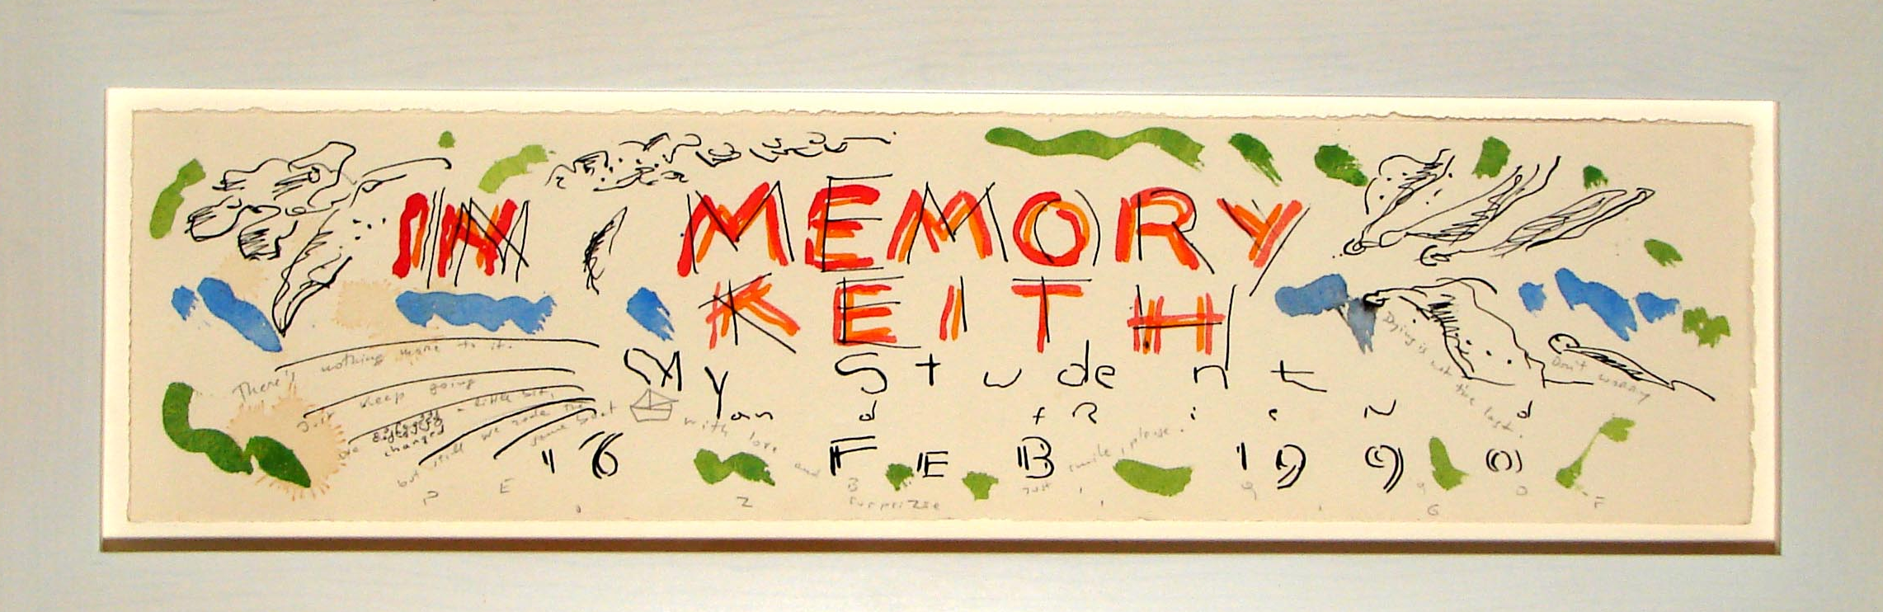
Exhibition installation view: Lucio Pozzi, In Memory of Keith, 1990, watercolor & ink on paper, 19” x 5”, Private Collection.
Put after Black and White KH, after the crib, put at end

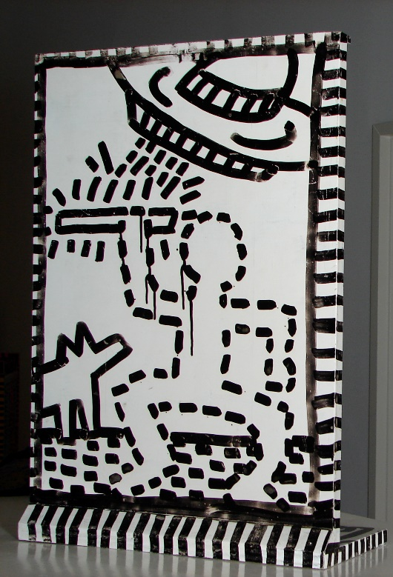
Exhibition installation view: Keith Haring, Untitled, 1981 marker and enamel on wood, 23” x 16” x 7”; created for and first exhibited at Hal Bromm Gallery in 1981 in “Keith Haring”, the artist’s first ever solo exhibition in a New York gallery.

Intermediate Interment
Carlo McCormick

As decades roll on, we’re all allowed a bit of selective amnesia. If Hal Bromm wants to remember the gallery’s thirty years of working with artists through a select four, so be it. Can’t say that I’m any less casual in my abbreviations, and certain figures do, well, have a wonderful way of standing in for the many, of helping us remember not just individuals but times of individualism. Guess I’m reminded most here of a certain outside, a space that always exists external to the art world, the studio, the mainstream and normal. I only know three out of the four selected for this show, but that’s where I did know them – at some exterior to the world we otherwise occupy. Maybe it’s because Hal’s such a freak he couldn’t help but locate his interests in some geographical and social margin, but he’s been pretty consistent in his aesthetics, generally preferring art in public places, preferably unlikely ones and often, let us say, un-commissioned. When you think about it, that’s not your typical modus operandi for a gallery.
When everyone was dying all at once around us there was this palpable worry that somehow we’d lose track. There were simply too many leaving too soon it seemed unfathomable that they wouldn’t just get lost in our ability to recall the full fabric of that time. Quite to the contrary, I find that even for the many who perhaps in the maelstrom of perpetual mourning did not get their full and proper goodbye, they remain acutely present still. Those we see now from time to time, friends of course but not so close as in the days of youth; they arrive now with the import of those absent. Yes, I remember, you were Keith’s friend. You, I’ll always love for the way you looked after Luis. And of course, how could I ever forget that time we shared together with David? Could any of us ever erase the image of looking at a once healthy friend sick and dying? No, but in the end, it is mostly those pictures we preserve in our minds of the vitality that sustain our understanding of what was and inter the physical dimensions of what was lost. This has little to do with how great or historically ratified any of these artists are in retrospect. It’s as true for me of those you’ve never heard of as it is for any with the mixed blessings of subsequent fame. In fact, the more others choose to remember, the less clear and personal our own anecdotal and incidental impressions become. Oddly, having written about these artists more than a few times since their passing, it’s not that we ever run out of things to remember or that remembrances become stale in any way, but one does become more aware of the process – how we remember, and how we remember the act of remembering. It is the mimetic device by which the sounds of laughter, the harshness of those words spoken in anger and even the uncomfortable silences that come in most relationships, are forever conjured in echoes.
Clubs were noisy and crowded; art shows had their own social politics; apartments were small and studio spaces (that is, studio visits) involved some discrete yet inescapable performance that was just slightly stilted, but what New York offers to this day is an almost incalculable expanse of public space – and this is where I still run into Keith and David and Luis in my mind’s eye. My best memories of them – not merely the happiest but the most indelible – are somewhere outside. Relationships with intense personalities all driven by compulsions that remained unspoken and were frequently not even known to those in their possession, were inherently tempestuous and (though loving) rife with ambivalence. It’s alright to say this; to own up to all these afflictive emotions as part of what is gone yet remains. In his eulogy to Luis Frangella, David Wojnarowicz screamed to the walls of Saint Marks Church how mad he was at Luis still, all the more because with his death he could no longer find the space to rectify whatever bit of stubborn dispute had come into their deep affection for one another. The conversations that were left unfinished were not those discourses that took place in the art world, the banter over nice meals or the witnessed interactions of a night on the town. Communication is what happens between neighbors over the proverbial picket fence, and, at least for that time in New York, that’s where art was decided.
Keith was likely the first guy we knew who took our collective passion for graffiti art closest to the heart of his art. He knew as well as anyone who the legendary New York writers where he’d run into late at night on the subways, but even subterranean he was too outside of the outlaws, never joining with them on the trains, but always talking to them from his critical distance upon the blacked-over empty ad spots. Ask those cats to this day, he was heard and understood all the more for not being in a crew. Personally, I can’t say I enjoyed much nice time with him in public – nor especially with the extremely shy David for that matter – but by chance encounter, wandering on night-empty streets, solitude was somehow more social. The first article I ever had published was about the art being made on an abandoned pier along the Westside Highway by David and Luis. Of course, careers connected, I followed them through the galleries and museums to follow, but everything we said – and I mean this for so many more people than could ever be fit in any group show – it was merely a continuation of the murmurs, whispers, nods and wordless musings by which we all first greeted, acknowledged and got to know one another outside of all that.
______________________________________________________________________________
Carlo McCormick is a curator, writer, and cultural critic. He received his MA in art history from Hunter College studying with theorist Rosalind Krauss and artist Robert Morris. David is currently a contributing editor of Art in America and a frequent contributor to Artnet News and Yale University Press online, among other publications. David is a member of AICA and the author of numerous artist monographs. McCormick's essay "Intermediate Interment" reflects on the legacy of these artists created for themselves- outside of the institutions of the art world- on the streets and for the people.

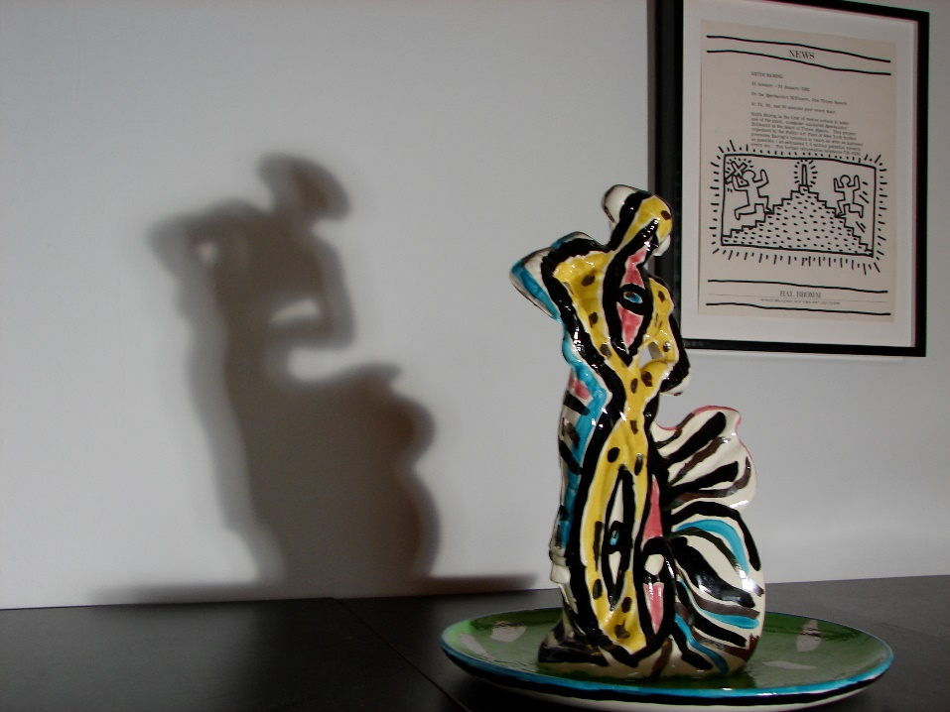
Exhibition installation view: (foreground) Carlos Alfonzo, Untitled (Toreador), 1985. Collection Pérez Art Museum Miami, gift of Hal Bromm; first exhibited at Hal Bromm gallery in 1987 in “Carlos Alfonzo”, his first solo exhibition in a New York gallery. (background) Keith Haring, Untitled (Spectacolor Billboard announcement (Hal Bromm Gallery Press Release)) organized by Public Art Fund, 1981 marker on paper, 11” x 8 ½” ; first Exhibited at Hal Bromm Gallery in 2005 during the “Vintage East Village” exhibition.

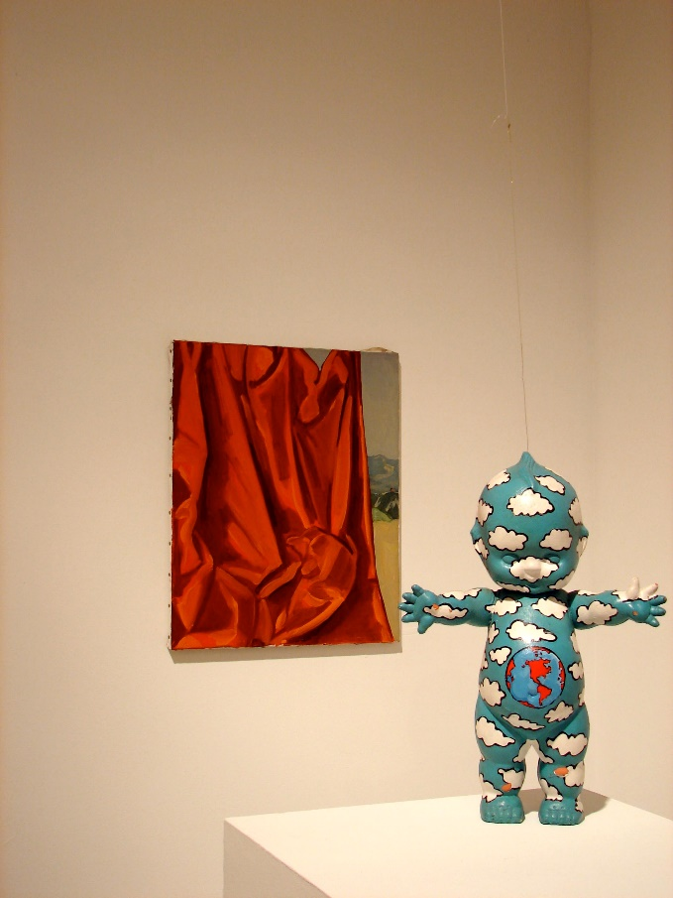
Exhibition installation view: (foreground) David Wojnarowicz, Evolution, 1985, acrylic paint on plastic doll (shown here, one of three elements), 17 ½” x 5” x 13”, Private Collection. (background) Luis Frangella, Untitled (Red Curtain Landscape), 1988, oil on canvas, 19 ½” x 15 ¾” ,Collection Gracie Mansion.

Sur’s Inquiry: Is Any of this News?
©Sur Rodney (Sur) 2007
David Wojnarowicz and I were born 5 weeks and 400 miles apart in 1954. We would find ourselves in conversation for the first time in 1983 or 4. On the day David learned he was HIV+, a framed photo portrait of him standing blindfolded in an abandoned west side pier, framed and hanging on my studio wall, crashed to the floor. The sound of the braking picture glass implying collision, a theme that would layer into David's thinking and being in art. Our mutual interest in people as characters, our familiar friends and acquaintances, and our fondness for Jean Genet, storytelling, and writing, gave us plenty to talk about. As suggested in both my sur name and naming, I identify with surrealisms. Dreams would often drift into our conversations. Learning of a letter that I'd written to David was archived in the Fales Library Collection at NYU, certainly piqued my curiosity.
From time-to-time David and I would exchange writing, always in person as I recall. Writing and posting a letter had escaped my mind, until I was faxed an envelope facsimile postmarked 21 May 1992, along with my type written pages describing a dream I had about Peter Hujar. The letter is addressed to David at the Cabrini Medical Center. Like most dream retelling, the details scattered and curious as I read...There was a woman behind me who was bothered by something I or Peter had said or how we were behaving together or something (can't recall) she stuck the tip of her umbrella up my ass...I thought it was Peter's finger. Peter was fond of derrières, but he never had mine. David had re-introduced me to Hujar who was, I will admit, generous with me. David would be generous as well, gifting me a silver print he had made in Hujar's darkroom, at cause to some homosexual pornography I had offered him? Probably nothing as treasured as our desire to possess what Keith Davis, our mutual friend and my lover for a time, kept in his archives. The print was more likely given to me for David's admiring of my collecting and archiving silver prints, a passion I'd acquired from my photographer father. This fascinated David--a shared love with a paternal parent. Something he had never experienced. The silver print was sold to finance a 1994 erotic surreal video classic directed by Jack Water's based on my poem Percodan & Wisdom. David would have read the original 1983 version and certainly would have encouraged the dream sequences in the film project his silver print had funded. Thank you David, for being so generous.
Luis Frangella was the most loved artist amongst his artist friends and sometimes collaborators. He had a particular fondness for David. Luis was influential in inspiration and generous in spirit and artistic production. The joy with which he collaborated with other artists, always remarkable. He could paint so effortlessly, expediently, and large. He had the most tender loving nature which served to temper so much of the frenzy around him. I've only ever heard anyone speak of Luis as though he were a guru. His effect on most everyone who met him seemed to highlight his benevolence. Something truly extraordinary.
I have a memory of purchasing a small colored pencil drawing of a horse from an exhibition of his work installed in Gracie's rear gallery when her gallery was on lower Broadway, in SoHo. I discovered, when returning to pick up the artwork, that there was a second drawing on the overside. Thank you Luis, for your generosity of being.
Keith Haring had solicited my help after moving into a studio in PS122, a former schoolhouse on First Avenue at 9th Street, in the early 1980s. During Keith's residency there, he was confronted by an African American artist (who also had a studio in the PS122 building at the time) who was on a rampage, because he thought the graphics Keith was producing were racist. Keith sought me out to visit his studio and respond to these concerns. My reading of them, as presented, was quite different. On display were several large sumi ink drawings illustrating figures interacting with each other. Albeit, they all seemed to suggest sex and violence, there was nothing I could detect in the work that was evidence to support this angry artist's claim. This was the first time that I had taken the time to really look and think about Keith's imagery. It often played out a scene with drawn figures that could be read as white or black determined by whether the figures were filled in (black) or not (white). For the most part, it was impossible to assume any power relationships between the figures as often they weren't interacting. When interaction between the figures appeared obvious, so was the message. The message in such instances appeared to mirror obvious injustices, not condone them. The work could be easily read as a statement on "race" relations, shocking in their insightfulness.
Keith would also on occasion invite me to be represented in his art exhibitions. I would oblige and always produce some creative manifestation at his request. In kind, he was as willing to return the favor and agreed to perform in a political propaganda film I was working on in response to my upset with a sidewalk guerrilla art project he initiated [delete words] with his buddies Drew Straub and John Sex. They had stenciled the sidewalks in the East Village with a message that read: CLONES GO HOME FAFH. I would learn that FAFH was a mnemonic for the trio's political group Faggots Against Facial Hair. In response, my political propaganda film featured a bearded drag queen. Thank you Keith, for your open generosity.
I've always perceived gay men, too many affected by the HIV/AIDS pandemic, and the women who loved them, as the essential engine that produced the East Village scene. When I think of David, Luis, and Keith--I find it difficult to separate them from a series of events and situations related to shared experiences with a group, collective, or whatever and whoever they were running with at the time. Each were generous and provided important links to isolated cells and clusters of unlikely associates. Each with their disappearance, at cause to HIV/AIDS, have isolated so many who since appear much less vibrant in the absence of their presence.
______________________________________________________________________________
Sur Rodney (Sur) is a writer, artist, archivist, and activist. As the former co-director of the Gracie Mansion Gallery, alongside his business partner Gracie Mansion, he frequently showed the works of David Wojnarowicz ("An Exploration of the Collisions in History in Reverse," 1986) and Luis Frangella. Sur was heavily involved in HIV/Aids activism, believing all art to be political ("Art Against Aids," 1987).

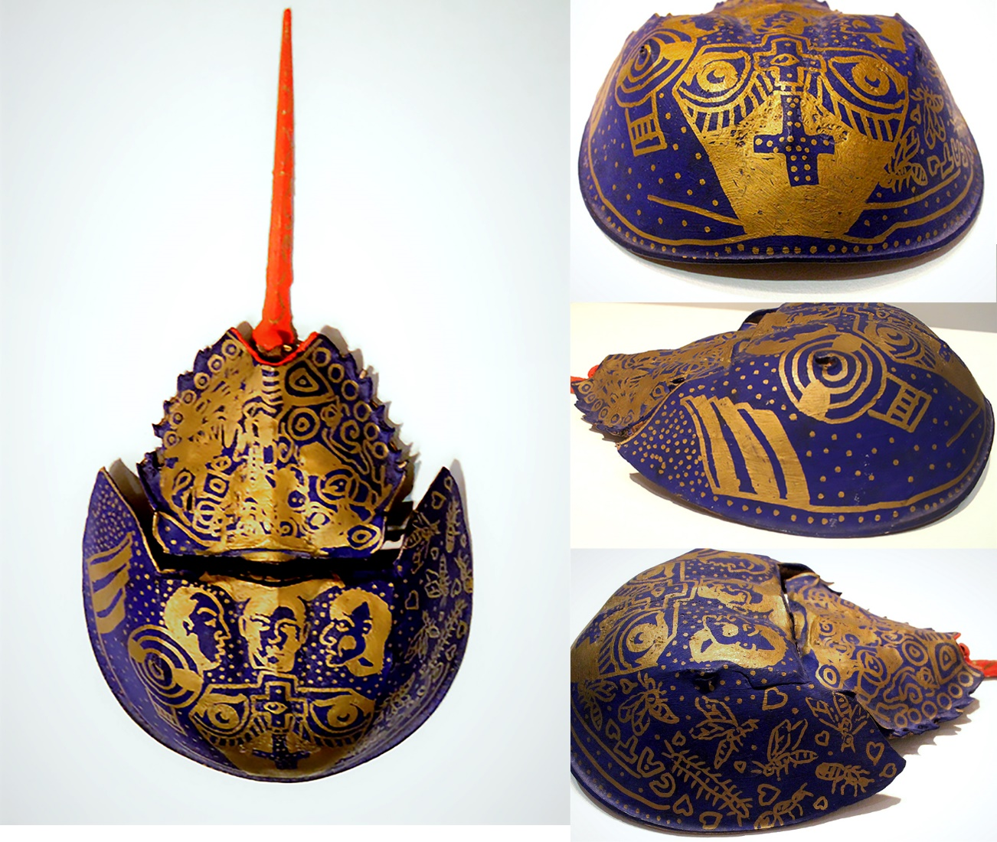
Exhibited work: Mike Bidlo, Luis Frangella, and David Wojnarowicz Untitled (Horse Shoe Crab), 1984 acrylic on found horseshoe crab shell 8” x 16” x 3”, Private Collection.

Luis and David among others
Some thoughts on the old crowd for a moment
Stephen Lack
Sept 16, 2007

I remember when Luis and David came back from a trip they took together to Argentina, Luis’ native land. They were both big guys but they seemed gentle, Luis seeming the gentler of the two, but you knew there must be another side, especially if you knew their work. No, I never saw the darker side, but I knew either one of them could ‘lose it.’ Harm Boukhart, the Swiss dealer, found that out when David slugged him after a dispute. In truth, David and Luis had a gentle and lively intelligence, and they were an oasis in what had degenerated to a grabbing and grasping sea of careerism and opportunism in the district. To me, they were two romantics, kind of huge, each in their own way: Luis playing and expanding his areas of interest and reality, large torsos and playful and brutal giant ‘Mickeys;’ while David raged against the political structures and the hypocrites of authority. Both artists’ brilliant execution only enhanced the content, and each had snagged the virus in their ‘research.’
While they were gone in Argentina some gallerists they were dealing with, maybe Gracie, maybe Dean Savard, were getting correspondence from them; so, we were updated a bit when they got back. About a week or so after their return I bumped into Luis on the street. He was a sort of quiet guy in that English wasn’t his native tongue, but he could say a lot with a few strokes. I asked him how it was? . . . “How was it to travel with David?” Luis rolled up his eyes in exasperation: “You know David” he said, sort of lovingly with a motherly sense of ‘fed up idness’ . . . “He is a bit crazy . . . you know he eats five meals a day… and in the jungle you can’t eat five meals a day . . . he was always hungry, drove me crazy.” In that one sentence, he had told me so much backstory.
David and I shared a lot of things: fire, animals, rage, and depression. I never felt I had to explain anything to him. When we first met installing the Famous show he already knew my work “Burning Limo in Beirut.” We had an easy friendship that survived a few tests, but we never got to go the distance we should have . . . I miss them both and can’t believe the blender of time has us spinning so fast that we never get to settle before we are spinning again. What lies ahead for us all could so benefit from their point of view: David’s analytic rage and Luis’ fragile reflections.
______________________________________________________________________________
Stephen Lack was a close friend of Luis Frangella and David Wojnarowicz. Lack frequently showed his work with the Gracie Mansion Gallery ("Stephen Lack + David Wojnarowicz," 1984). In his essay, "Luis and David among others," he describes the gentle relationship between Frangella and Wojnarowicz, what they shared and where they differed.

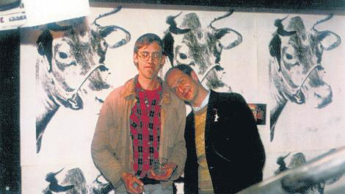

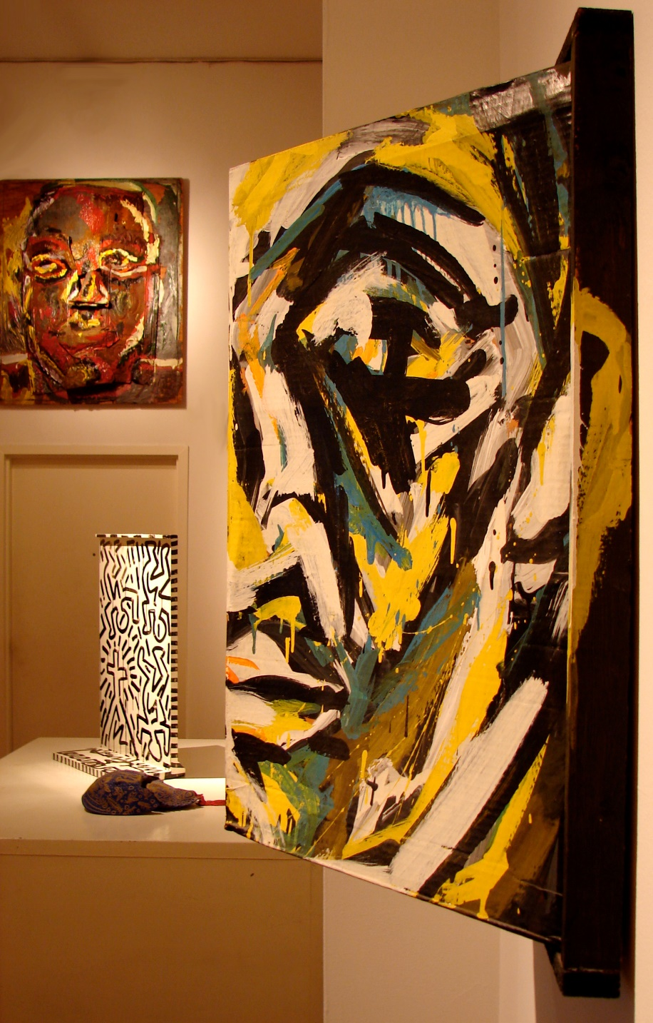
Exhibition installation view: (foreground) Luis Frangella, Carmen, 1984, Acrylic on cardboard with artist’s’ frame, 28” x 26.5” x 13”, Private Collection. ( middle-ground) Mike Bidlo, Luis Frangella, and David Wojnarowicz Untitled, 1984 acrylic on found horseshoe crab shell 8” x 16” x 3”. (middle-ground) Keith Haring, Untitled, 1981 marker and enamel on wood, 23” x 16” x 7”; created for and first exhibited at Hal Bromm Gallery in 1981 in “Keith Haring”, the artist’s first ever solo exhibition in a New York gallery. (background) Luis Frangella, Untitled (Face), 1984, Mixed media and collage on wood, 48.5 x 38.5 in, Private Collection.

Carta a Luis

Dearest Brother:

How are you? This is going to be one more of our usual talks to you....since you have physically left us....so, let me put it in writing.
I´m sorry if I tell some secrets. The thing is that, most of the time, you appeared to others serious, shy and reserved, but somebody always generous to everybody.
For me, as we were so close in our childhood (you were my idol, remember?) it was easy to understand each other with just a smile or a look in each other’s eyes. Maybe it was easy because of the beloved presence of “mamá,” with her brilliant imagination and fine sense of humor, she influenced every aspect of our lives. I can´t imagine our lives without her inclination to ART, which was so well understood by you and Roberto.
Now, living in Europe, lots of your thoughts I understand better. Here, the places you visited and enjoyed so much...
Talking with your friends (Russ, Manuela, Adriana, Hal) is like capturing the best of you: LUIS THE ARTIST. Looking at your beautiful paintings that hang in our homes, is where I can find those clever impressions you could so well transmit. They accompany our everyday life.
So, Luis, here once again, is my love and respect to you.
Alberto and our children still remember our moments together in “Santa Cecilia,” riding on horseback, teaching them how to draw, preparing “Spanish tortilla,” tasting “los asados de papá,” my “dulce de leche casero,” you wearing “ bombachas y alpargatas;” you bringing funny Christmas presents from New York....
So, hang on, we are always very near...
Till we meet again

Lia Maria Frangella
______________________________________________________________________________
Lia Frangella-Malacorto is Luis Frangella's sister. They grew up together in Argentina. In her letter to Luis, she tells him that, through his friends, her travels, and his art, she understands him better than she did before. His legacy both as an artist and her dear brother survives.

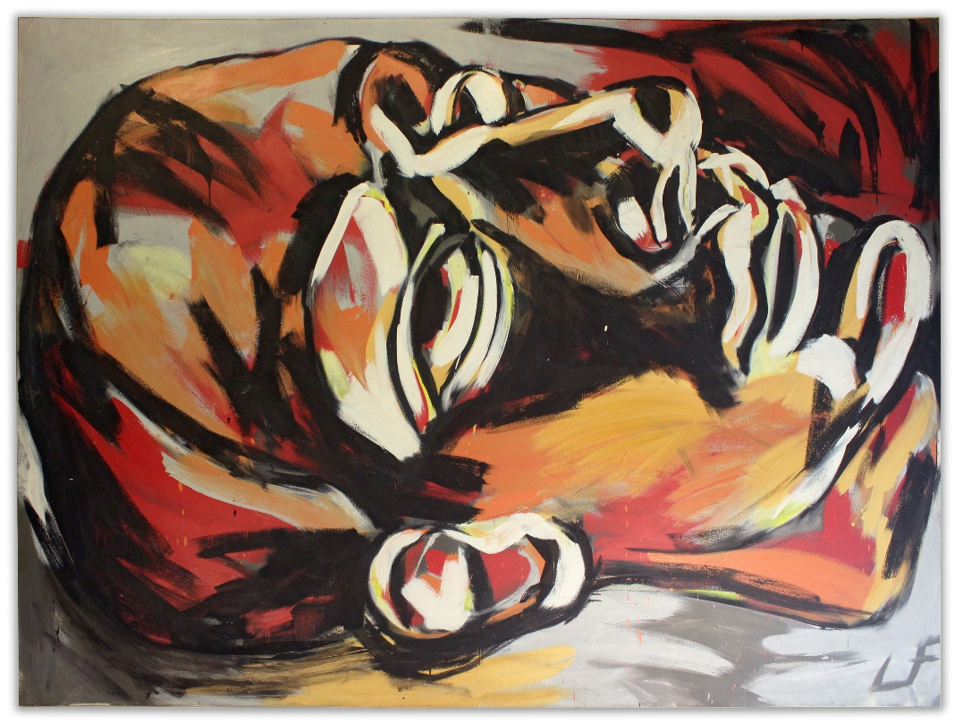
Luis Frangella, Dreamer, 1983, oil on canvas, 108” x 136”

Fade Away and Radiate
Barry Blinderman
Oct 4, 2007, Normal, IL
These days I am an “outsider” in seeing an art world inflated beyond belief recognition, all the while backed by latter-day robber barons, wracked with cynicism, mired in professionalism, and signed and sealed in among an endless expanse of indistinguishable fortresses. So, it is no wonder that my own thought-dreams should drift ever more readily to the New York art scene of the early 1980s, characterized by its tumult, euphoria, vitality, and breakneck speed.
There’s Keith Haring, parking his bicycle on Houston at Bowery to admire the fruits of a hard day’s work—a colossal and lurid electric-colored mural with twin pair of pink, three-eyed, leering faces bookending four inverted, acid-green, dancing figures like some cartoon Pompeian ruin. Minutes later, he might be stepping off the #6 uptown train to speedily fill-in fortuitously blank ad panels with cryptic, mythic chalk-drawn visions of ever-mutating creatures—frolicking, fighting, or fleeing from their myriad nemeses. Meanwhile, Kenny Scharf is spray painting a Jetsonian space tower and serpent-tailed Rosie the Robot on a playground wall on-route from his Long Island City studio to his East Village apartment. Once there, he’d likely be festooning telephones, radios, and vacuum cleaners with hot-glued dinosaurs and baubles, then slapping on squiggles of fluorescent paint.
You could also make a trip to stand at the phone booth on the corner of Ridge and Stanton and attempt to interrupt one of Martin Wong’s interminable phone-while-you-paint conversations to follow him up six flights of stairs—circumventing a comatose junky with a needle still in their arm—and hold your breath for as many floors as possible to avoid the stench of stale cat piss. Squeezing past the floor-to-ceiling graffiti art collection in the hallways of his cramped four-room apartment, you’d watch entranced as he painted poets and tramps amidst the deteriorating brick facades of neighborhood tenements that might be razed before your next visit.
Far across town David Wojnarowicz, Mike Bidlo, Luis Frangella, and others are enacting a self-styled extreme makeover inside a crumbling, abandoned shipping warehouse along the Hudson. The dank, compounded residue of clandestine rendezvous is palpable as this band of merry mythophiles trade riffs on their paint-loaded instruments, belting out conjuring dazed gagging bulls, a true-to-scale Pterodactyl, a retake track of jazzman Jackson P ”Jack(son) the Dripper,” and a bravura frieze of gargantuan, headless classical male and female nudes. Wojnarowicz had discovered the disintegrating pier warehouses as a teen, seeking refuge from the Midtown street corners on which he had hustled from the age of ten. His camera loaded with film pilfered from drugstores, he would shoot hundreds of black and white photographs of hookers and drag queens strutting along the Hudson, then check the undeveloped rolls in bus station lockers and, as if karmically, neglect to reclaim them. David’s written accounts, though, of men roaming and hooking up in an endless succession of warehouse rooms still survive in his published works, as do his observations on “sitting with the entire city at [his] back and looking at the river,” projecting himself “all around the world . . . by looking at those qualities of light in the late afternoon skies. . .” [interview with author, October 1999].
In retrospect, the a common thread in these artists’ gestures seems appears so clear: it is transience, manifested by marks inscribed on paper soon to that would soon be pasted over, paint applied to decayed walls soon to be demolished, moments of sureness just as fleeting as the characters I now type on this screen. Four of the six artists I’m talking about here are long gone, felled by an insidious virus, leaving behind images and messages that resonate in our memories and are already inscribed in art history.
Cut to Normal, Illinois, in the winter of 1990, and I’m in the middle of a national controversy over images reproduced in the David Wojnarowicz: Tongues of Flame: a catalogue we published on the occasion of his 10-year retrospective at University Galleries. Elizabeth Hess flies out for the opening and her feature article in the Village Voice is headlined “Queer in Normal.” David reads to a crowd of 700 people, all riveted by his passionate rants against church, government, and other purveyors of the oppressive “pre-invented world.” Within two weeks a local ACT UP chapter has formed. Right-wing California Congressman Dana Rohrbacher’s proclamation of David’s show as “an orgy of degenerate depravity” remains the highest honor I’ve ever received as a curator. And the lawsuit that ensues against screwball media monitor Donald Wildmon, head of the American Family Association, even tops that; the hypocritical dope collaged and xeroxed racy details of David’s work and mailed them by the thousands without the artist’s permission. David joked about his token award of one dollar after a protracted battle—that depending on his mood, he’d spend it either on a condom or an ice cream cone.
It’s a little- known fact that the image of skeletons in David’s gut-wrenching photo-text montage When I Put My Hands on Your Body came from a 35 mm black and white photograph the artist shot surreptitiously at Dickson Mounds, a Native American burial site near the Illinois River. He also made the three large collaged “Flower” paintings in a studio he rented in an old warehouse beneath a bridge at the edge of Bloomington. Moreover, David shot the haunting yet comical Death in the Forest—with studio assistant Patrick McDonnell as a cardboard totem—in a wooded area right outside town, and the ridiculous Jesse Helms as Nazi spider collage on my front porch. Despite his chronic nausea from the AZT he was taking, David loved the months he stayed in central Illinois, mingling as he did for the first time with university students...
Although many are familiar with David’s acerbic tone and short fuse, few have remarked on his wicked sense of humor. At the breakfast table, he often delighted my five-year-old son with instant drawings of gap-toothed monsters, and a memorable one of our scrawny toy poodle, bolting in flames from our burning house.
______________________________________________________________________________
Barry Blinderman is a curator, writer, educator, and singer-songwriter. He directed Semaphore Gallery, Semaphore East in Soho, and the East Village. As the director of University Galleries of Illinois State University from 1987 to 2018, he curated the first traveling museum exhibition in the United States for David Wojnarowicz and Keith Haring, among others.

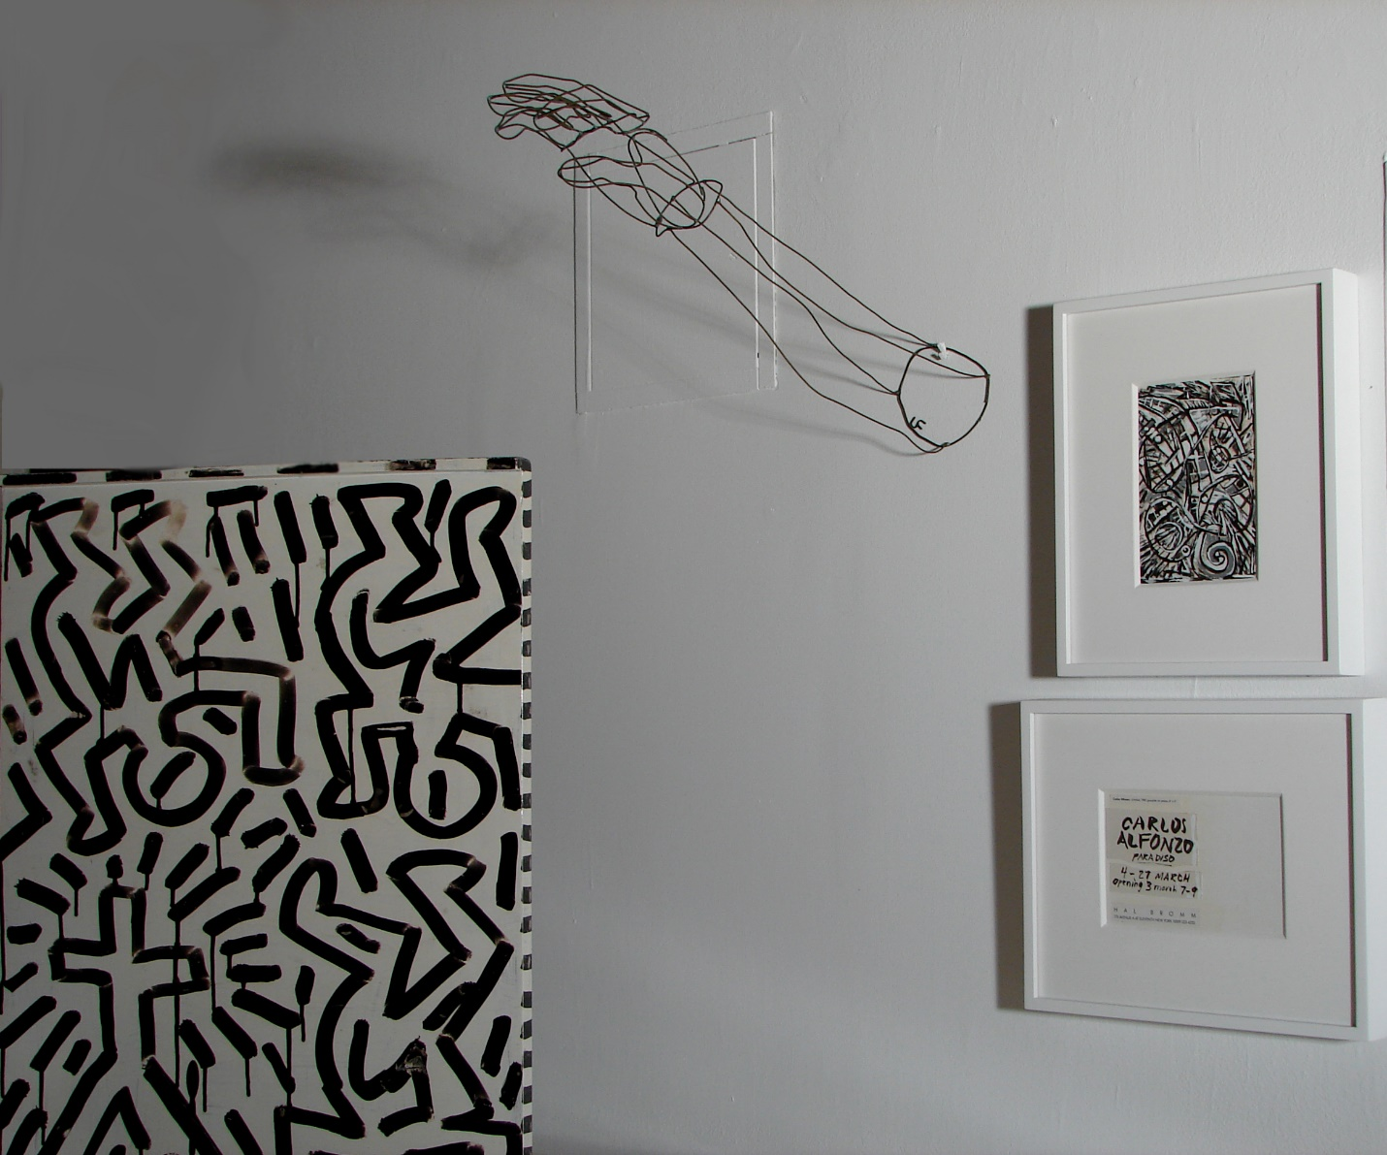
Exhibition installation view: Keith Haring, Untitled, 1981 marker and enamel on wood, 23” x 16” x 7”; created for and first exhibited at Hal Bromm Gallery in 1981 in “Keith Haring”, the artist’s first ever solo exhibition in a New York gallery. Carlos Alfonzo, Paradiso, 1987, exhibition announcement card text designed and painted by the artist, ink on card, 4” x 6”, Private Collection. Carlos Alfonzo, Untitled, 1987, Paradiso announcement card image, ink on card, 6” x 4”, Private Collection. Luis Frangella, Hand, 1980, brass wire, 19 ½ x 3 ½” x4”, Collection Barbara and Ira Sahlman.

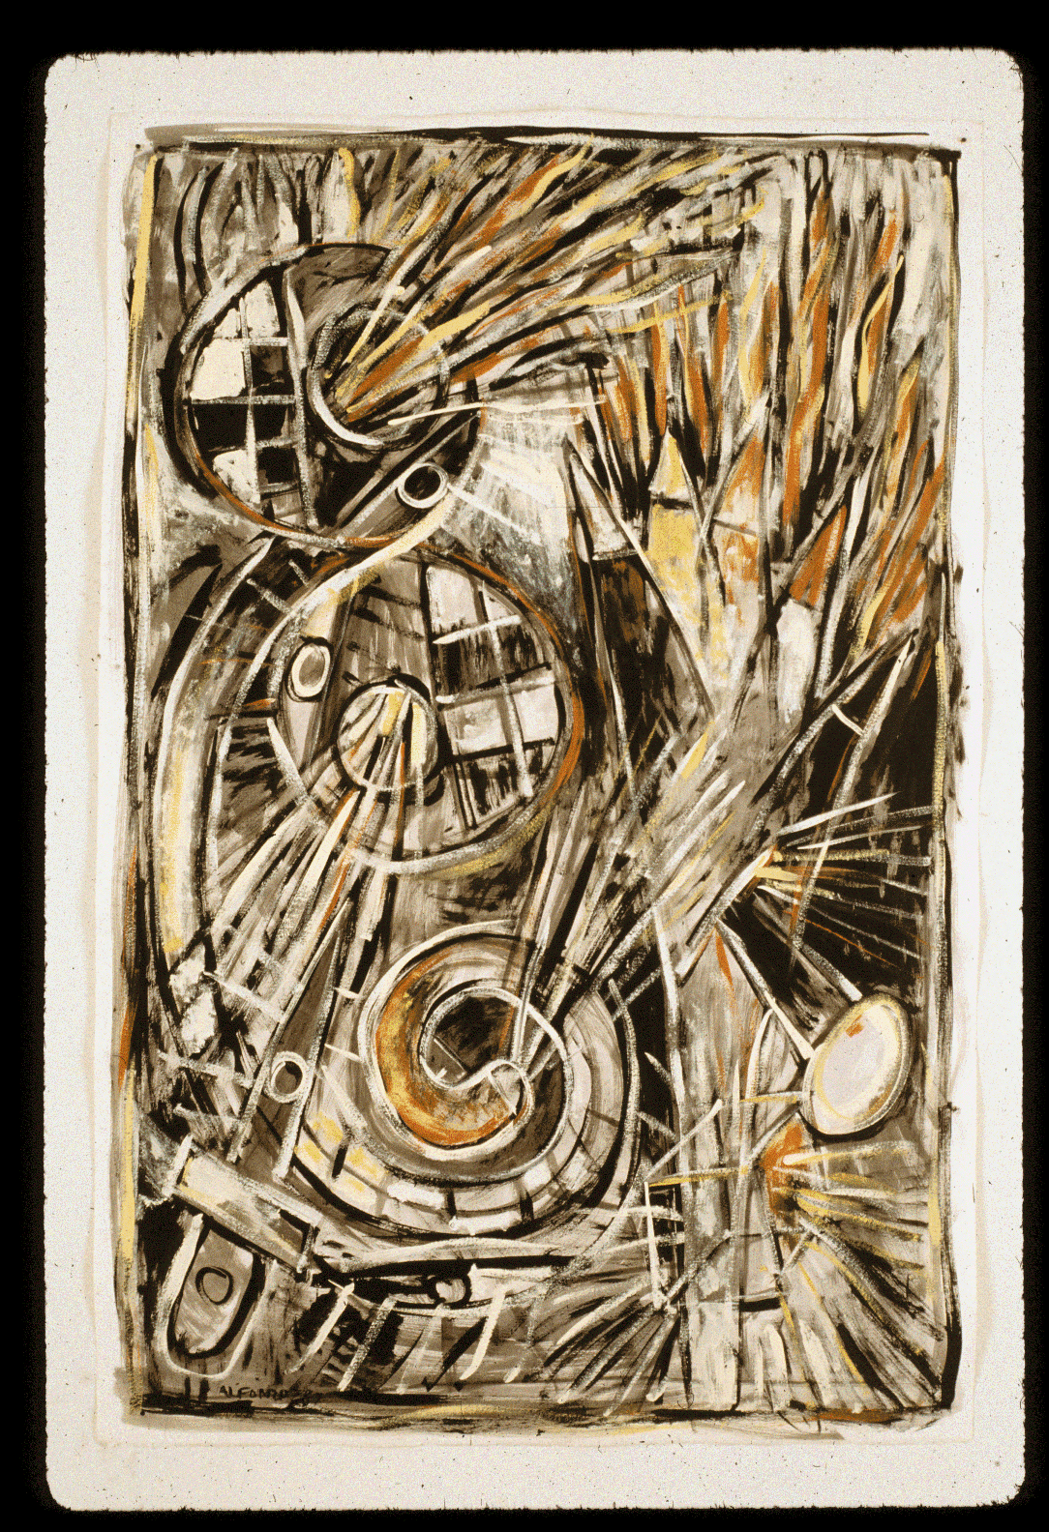
Carlos Alfonso, Untitled, 1987, ink, tempera, and gouache on paper, 48” x 31 ½”, signed: Alfonso 87.

FLASH IN OUR WORLD: Carlos J. Alfonzo
César Trasobares
Miami, September 2007
Carlos José Alfonzo studied art at Havana’s San Alejandro Academy of Fine Arts earning recognition and support as a young and promising intellectual in the strict cultural circles of the Revolución Cubana. To the surprise of many of his Compañeros, he seized the first opportunity to leave the island, traveling across the treacherous Florida Straits on a crowded fishing boat as part of the Mariel Exodus. Throughout the rest of his life, he would remain wounded “by politics and social contracts” (governmental, religious, sexual) even as he became a fearless artist willing to push all the limits.
Arriving in Miami in 1980, Alfonzo had to take whatever jobs were offered to start his new life. Soon he began to have free time, and confident in his artistic style and solid technical education, he first painted small works, eventually moving to larger formats. As he became more established, he experienced a boundless release of emotions and ideas, which bolstered his constant artistic expression, his relentless descarga, his “unloading.”
The art of Carlos Alfonzo reveals the dizzying world of a driven visionary who expressed his evolving artistic selves and recorded an immigrant’s longings and tears. Because he had grown up in a Marxist national culture, his imagery was initially driven by acceptable social codes and by the pictorial tradition of Cuban modernism. In the United States, intensifying his vivid interest in the human body as a subject, he began to paint “the drama and poetry of the everyday.”
After living in Los Angeles briefly in 1983, he set up his home in Miami. He traveled to New York and Texas for his exhibitions and visited museums and galleries to see work by contemporary artists he admired. In 1986, walking through Italian churches and museums, he felt “fulfilled, inspired and energized” by the Old Masters. Soon thereafter, by the mid 1980s Alfonzo was working in a large studio in Miami Beach, solely dedicated to his art, producing dynamic, charged compositions of great presence, scale, and power.
His mature paintings are full of tension and movement, often composed like a stage where some drama is unfolding. For Aurora Borealis, he found inspiration in a charged erotic scene from Lezama Lima’s Paradiso. Anunciación is suffused with the Baroque images and golden light Alfonzo encountered in Italy. In Gulfstream, he recalled his own perilous maritime flight. La Noche Oscura, Next to a Dog, In Peace, Three Drops, and The City embody the brutal power of his striking large compositions and demonstrate his vast range as a painter and as an acute observer of his personal, cultural and social milieus.
Alfonzo was thoroughly familiar with art history and esthetic theory. He also had a special interest in arcane symbols and the iconography of Santería, an Afro-Caribbean religion with roots in Yoruba culture. In 1987, he produced an important suite of paintings intended for a temple that was never built. Each panel included the image of a specific orisha, or deity. Extending their pictorial syncretism, he painted symbols familiar to initiates (Changó’s double ax, Babalú Ayé’s muletas). As a Santería practitioner and believer, Alfonzo’s involvement with sacred images was motivated by faith and informed by peers, padrinos, and Lydia Cabrera’s books. Eventually, he became involved with the philosophy and practice of the Rosicrucians, strengthening and deepening his religious convictions.
Producing sculptural versions of his complex pictorial visions, Alfonzo worked in ceramics and welded steel. In a group of large sculptures, Ballerina Suite, he transformed his painted prima donnas into life-size, quivering metal divas. Using delicate lines, he painted the Santería pantheon in a group of small ceramic plates. With clay, he made models for benches and park furniture. In the tradition of playful modernists, Alfonzo enjoyed painting and incising dishes as well as forming them by hand. A group of large plates criticized “Cuba’s false cultural freedom and the use of ballet and folklore as smoke screens.” He would occasionally paint a campy teapot or a wild ashtray, “so I won’t be taken so seriously.” By 1986, life and art had merged seamlessly, and Alfonzo was becoming a celebrity.
Curators who organized surveys and touring exhibitions immediately recognized Alfonzo’s genius. Invitations to important exhibitions followed and continued through the years. Critics reviewing these exhibitions received his works favorably, and broad audiences came to experience his paintings in museums and galleries across the United States. One of his paintings is featured on the cover of the catalog of Hispanic Artists in the United States (1987), an ambitious survey of Latino artists. He worked with various dealers in Miami, New York, Houston and Washington D.C., and his exhibitions usually sold out. Collectors also courted Alfonzo, acquiring paintings for their homes and to donate to museums. He had many artist friends.
Important public art commissions bolstered Alfonzo’s growing prestige. In Ceremony of the Tropics, a ceramic mural for a Miami public transport station, he references the neighborhood’s markets. The mural depicts “the ritual of taking fruits and vegetables and turning them into objects of devotion and worship.” In the lower part of the composition, a representation of Eleggua alludes to the deity’s power of closing and opening doors as the guardian of transfers between physical and spiritual realms. In Brainstorm, at the Engineering and Computer Science Building on the campus of Florida International University, Alfonzo celebrates an inner world of “exploding ideas and thinking.”

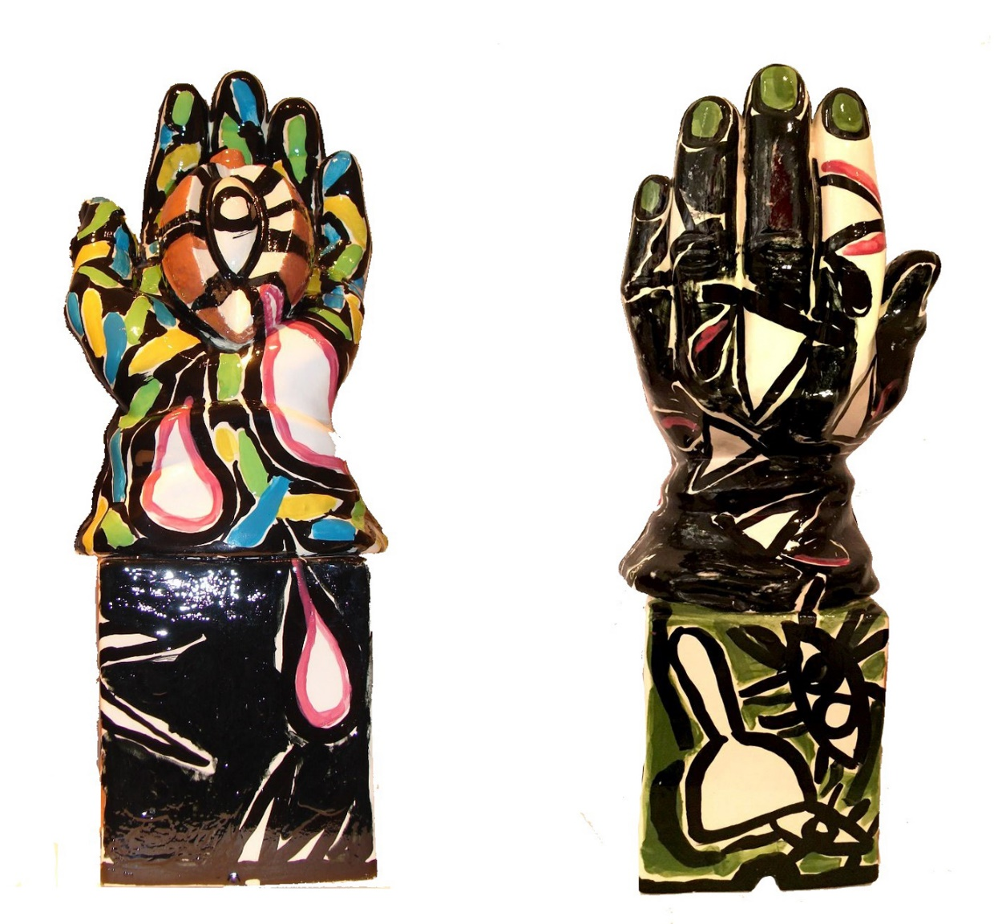
Carlos Alfonzo, Hand with Mamey (front and back), 1985, glazed ceramic, 15” x 6” x 5”, Private Collection; first exhibited at Hal Bromm Gallery in “Carlos Alfonzo” (1987).

In 1989, Alfonzo began his “black” paintings. Witnessing his body becoming frail and weak as he endured living with the AIDS virus, he recorded the transcendence of his own person from flesh into spirit. He shared and defied the position of the “Pandemic outcast” with numerous other HIV+ artists living in Miami and with the larger pan-AIDS community of artists everywhere. As he worked on the large paintings, he produced the drawings for a book in a small edition, Habitual, which was never officially released. The exhibition of his daunting paintings at the Bass Museum revealed the artist’s immense drive and gravity. This time he acknowledged his looming mortality and the peaceful passage he was seeking. The late Giulio V. Blanc, a friend and avid critic, wrote in the catalog of Alfonzo’s last solo exhibition:
“The ‘black paintings’ are attempts to fathom, and thus conquer, existence at the end of the millennium. One has to return to the heroic paintings filled with myth and universality, that were the Abstract Expressionists’ answers to the war, the Holocaust and the birth of the atomic age, to find comparable intentions and results in the art of the past fifty years…”
Alfonzo’s death at the age of forty of a cerebral hemorrhage cut short his prodigious career. In acknowledgement of his singular contribution, four of his paintings were included in the 1991 Biennial of American Art at New York’s Whitney Museum. The Miami Art Museum organized a major retrospective in 1997, followed by another comprehensive and inspired survey in 2006. His star continues to rise.
______________________________________________________________________________
Cesar Trasobares is an artist, art activist, author, public art consultant and curator. He was a close friend of the late Carlos J. Alfonzo and now oversees his estate. Trasobares served as curator for a posthumous exhibit of Alfonzo's work at the Pérez Art Museum Miami (PAMM) ("Carlos Alfonzo: Clay Works and Painted Ceramics," 2016). Trasobares's essay "FLASH IN OUR WORLD: Carlos J. Alfonzo" celebrates the accomplishments of Alfonzo and details his artistic evolution.

Bibliography
Triumph of the Spirit: Carlos Alfonzo, A Survey. Catalogue of the exhibition organized by Olga M. Viso for the Miami Art Museum in 1997. Essays by Olga Viso, Giulio V. Blanc, Dan Cameron, Julia P. Herzberg and César Trasobares.

CARLOS ALFONZO: Extreme Expression, 1980-1991, Organized by Juan P. Loumiet with Julia P. Herzberg, Curator, Bridge House Publishing, Miami: The Freedom Tower, 2006.

Quotes are from conversations with the author on various dates.

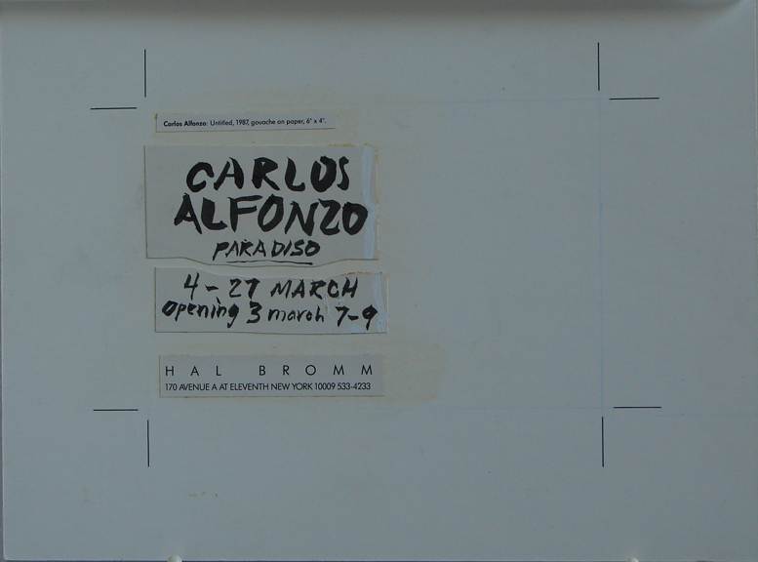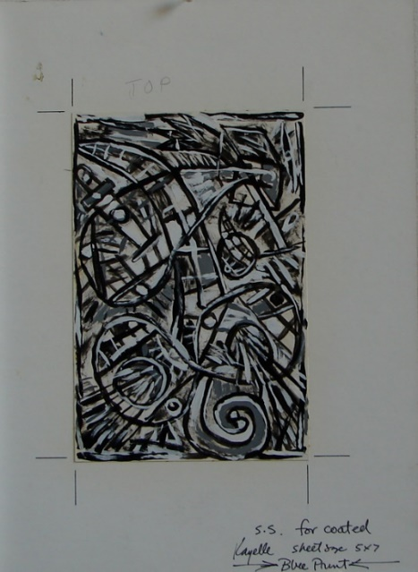
Carlos Alfonzo, Untitled, 1987, Paradiso announcement card image designed and painted by the artist, ink on card, 6” x 4”, Private Collection

Exhibition List

1. Luis Frangella Dreamer, 1983 oil on canvas
108” x 136”

2. David Wojnarowicz The Four Elements, 1990
four color lithograph, diptych
edition 21/24
24 ¾” x 30”

3. Carlos Alfonzo Untitled (Hand with Mamey), 1985
glazed ceramic
15” x 6” x 5”

4. Luis Frangella Untitled, 1988
(Mauve Curtain Landscape)
oil on canvas
19 ½” x 15 ¾”
Private Collection

5. Luis Frangella Head, 1984
mixed media and collage on wood panel
48 ½” x 38 ½”

6. Luis Frangella Early Seduction, 1983
oil on canvas
92” x 120”

7. David Wojnarowicz Untitled, 1982
acrylic on masonite, diptych
4’ x 8’

8. Keith Haring Crib, 1981
enamel & marker on found crib
42” x 55” x 30”

9. David Wojnarowicz Evolution, 1985
mixed media on 3 plastic dolls
Each: 17 ½” x 5” x 13”
Overall: 17 ½ x 5 x 45” (dimensions variable)

10. Luis Frangella Untitled, 1988
(Red Curtain Landscape)
oil on canvas
19 ½” x 15 ¾”
Collection Gracie Mansion

11. David Wojnarowicz Prison Rape, 1984
acrylic paint collage on masonite
4’ x 4’
Borrowed from private Collection

12. David Wojnarowicz Untitled, 1990
silkscreen edition 43/100
2 sheets, each 23” x 27”
framed 49” x 29 ½” overall

13. Carlos Alfonzo Untitled, 1987
ink, tempera, & gouache on paper
48” x 31 ½”
signed: Alfonzo 87

14. Carlos Alfonzo Maternity #2, 1989
acrylic on paper
32” x 48”
Courtesy George Adams Gallery

15. Lucio Pozzi In Memory of Keith, 1990
watercolor & ink on paper
19” x 5”
Private Collection

16. Keith Haring Untitled, 1982
Spectacolor Billboard announcement
(Hal Bromm Gallery Press Release)
organized by Public Art Fund
marker on paper
11” x 8 ½”
Private Collection

17. Carlos Alfonzo Untitled (Toreador), 1985
glazed ceramic
12 ½” x 10 ¾”

18. Luis Frangella Head, 1984
acrylic on cardboard box
28” x 26 ½” x 13”

19. Luis Frangella and Untitled, 1984
David Wojnarowicz acrylic on found horseshoe crab shell
Collaboration 8” x 16” x 3”
Mike Bidlo Private Collection

20. Carlos Alfonzo “Paradiso” , 1987
Paradiso exhibition announcement card text
designed and painted by the artist
ink on card
4” x 6”
Private Collection

21. Carlos Alfonzo “Paradiso” 1987
Paradiso exhibition announcement card image
designed and painted by the artist
ink on card
6” x 4”
Private Collection

22. Luis Frangella Hand, 1980
brass wire
19 ½ x 3 ½” x 4”
Collection Barbara and Ira Sahlman

23. Keith Haring Untitled, 1981
marker and enamel on wood
23” x 16” x 7”
Private Collection

